Nazareth Village
This video shows how things were in the time of Jesus. Many things look different to now.
There are some questions to answer and things to do about that time. You can print these sheets or complete answers on a piece of paper.
- In the workshop there are many tools. Draw and name one that you saw.

- Draw a modern-day tool that someone in your family uses.

- Name some of the foods that you saw in the kitchen. ______________________________________________________________________________________________________________

- Do you eat any of those foods today? __________________________

- Draw your favourite meal from today.

- In Hannah’s workshop she was weaving and made beautiful, warm scarves. What animal provided the wool? ______________________________
- Did you see any other animals? _______________________________
- Look at the houses and furniture. They are made from bricks and wood. Try to make a house out of Lego or blocks or something else so that it looks a bit like a house from that time. Then take a photo and show us or draw a picture.
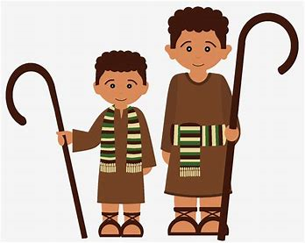
- Notice the clothes. They are plain and simple. Many people wear head coverings. Try to dress a doll or teddy or yourself to look that way. Then take a photo and show us or draw a picture.

